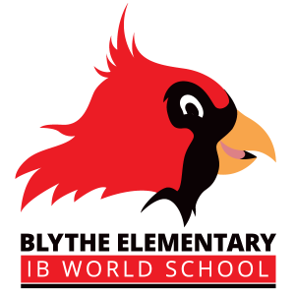**Kindergarten Supplies 23-24**

* Student backpack big enough to fit in a full sized folder
* A labeled refillable water bottle that will be left at school
* 2 Packs of Pre-Sharpened Pencils (Ticonderoga Are the Best!)
* 1 Red Thick Plastic Folder (Mead 5-Star Brand is durable enough to last) with Prongs and Pockets
* 3 Boxes Crayons (24 Count) (Crayola Are the Best!)
* 2 Packs Dry Erase Markers (One Fat and One Skinny) *All Black *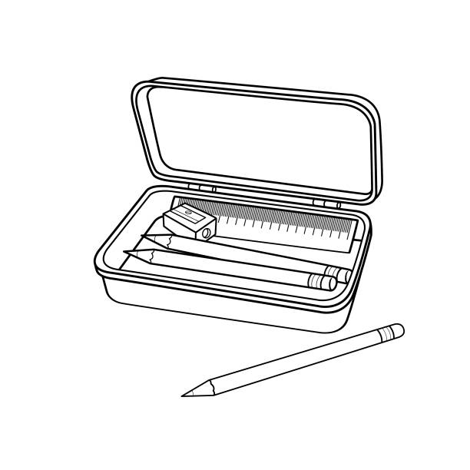
* 1 Pack Chunky Erasers
* 1 Standard Size Plastic Pencil Box 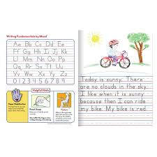
* 12 Glue Sticks
* 1 Pair Blunt-Tip Scissors
* 1 Ream colored copy paper
* 1 Mead brand primary journal ** the paper is half blank and big writing lines**
* 1 Box Gallon Sized Zip Lock Bags
* 1 Container Baby Wipes
* 3 Boxes Tissues
* 1 Pair of Over-The-Ear Headphones to Be Left At School to Use with IPads (No Bluetooth or Wireless)
* Change of clothes to be left at school in case of accident or spills

**Boys please bring**

* 1 Box Dixie Cups
* 1 Box of Snack Size Bags
* 1 Pack of White Card Stock Paper
* Hand Sanitizer
* 1 Box Children’s Band Aids

**Girls please bring**

* 1 Box Quart Size Bags
* 1 Pack of Colored Card Stock Paper
* 1 Pack Washable Markers (Crayola are the best!)
* Lysol/Clorox Wipes
* 1 box sandwich size bags

**\*Some of these supplies will be community supplies. Please wait until open house to label. \***





**1st Grade Supplies 23-24**

* 2 Boxes #2 Ticonderoga Pencils (Sharpened)
* 2 Boxes Crayons- 24 Count
* 1 Box Expo **Black** Dry Erase Marker
* 2 Packs Pink Pearl Eraser
* 1 Pencil Box / Pencil Pouch
* 8 Glue Sticks
* 1 Ream Copy Paper
* 1 Spiral Notebook
* 3 Black and White Wide Ruled Composition Notebooks (not primary journals)
* 1 Poly Pocket Folders **with** Prongs
* 1 **Red** Poly Pocket Folders **without** Prongs
* 1 Pair 5” Blunt Scissors
* 2 Boxes Tissues
* 1 Bottle Class Size Hand Sanitizer
* 1 Pair Headphones (No Earbuds Please)
* 1 Reusable Water Bottle
* 1 Box of Highlighters

**Boys Please bring**

* 1 Container Lysol Wipes
* 1 Box of Sandwich Size Ziploc Baggies

**Girls Please Bring**

* 1 Container Baby Wipes
* 1 Box of Gallon Size Ziploc Baggies

**Wish List Items:**

* Washable Crayola Markers
* Colored Pencils
* Card Stock (White and Colored)
* Paper Towels
* Sheet Protectors

***\*Some of the supplies will be used as a community\****



| **2nd Grade Supplies 23-24**   * 3 Boxes # 2 Sharpened Pencils * 2 Boxes 24 Count Crayons * 1 Box Washable Markers * 1 Pack Black Dry Erase Markers * 1 Pencil Pouch with zipper * 4 Jumbo or Regular Glue Sticks * 1 Package Wide Ruled Notebook Paper * 3 Wide Ruled Composition Notebooks * 1 Pack Colored Copy Paper * 2 Packs White Copy Paper * 1 of each 2 Prong Plastic Folders (Red, Blue, Yellow, Green) * 2 Packs Sticky Notes * 1 Pair Scissors * 2 Boxes Tissues * 1 Container Clorox Wipes * 1 Bottle Hand Sanitizer * 1 Box of Storage Bags (Girls Bring Gallon Size, Boys Bring Sandwich Size) * 1 Box Band-Aids * Reusable Water Bottle * 1 Pair Headphones~ Over The Ear Ones Work Best   **Wish List Items**  Outdoor Recess Equipment  White Cardstock Paper  Colored Cardstock Paper  8 ½ X 11 Laminating Pouches  http://blythepta.com/wp-content/uploads/2018/08/BTS1.jpg |
| --- |

**3rd Grade Supplies 23-24**

* 2 Boxes #2 Ticonderoga Pencils (Preferably Sharpened)
* 1 Box Colored Pencils- 12 Count*
* 1 Box Crayons- 24 Count*
* 1 Box Washable Markers- 8-12 Count*
* 1 Box Expo Dry Erase Marker
* 2 Packs Bar Erasers (Pink) (No Pencil Toppers Please)
* 1 Pencil Pouch *
* 3 Glue Sticks
* 2 Reams Copy Paper
* 5 Composition Notebooks*
* 5 Plastic Pocket Folders With Prongs (Red, Blue, Yellow, Orange, Green)*
* 1 Pair Scissors*
* 4 Boxes Kleenex Tissues
* 1 Pack Clorox Wipes
* 1 Bottle Hand Sanitizer
* 1 Set Headphones (No Earbuds Please)*

**\*Please label these items with your child’s name**

**Boys please bring**

* 1 Box Band-Aids
* 1 Box Gallon Bags

**Girls please bring**

* 1 Box Quart Bags
* 1 Box Band-Aids



**4th Grade Supplies 23-24**

* 2 Packs Pencils (Pre-Sharpened)
* 1 Box 24 Colored Pencils
* 1 Box Washable Markers
* 2 Packs Expo Dry Erase Markers
* 1 Pencil Pouch
* 4 Composition Notebooks
* 3 Reams Copy Paper
* 4 Pocket Folders (With Prongs)
* 1 Pair Blunt-Tip Scissors
* 3 Boxes Tissues
* 1 Pack (3 Included) Clorox Wipes
* Post it notes
* 1 Pair Personal Headphones (To Keep & Use at School)
* Girls - Bring one box of Bandaids
* Boys - Bring one box of Ziploc Bags

***\*Some of the supplies will be used as a community\****



**5th Grade Supplies 23-24**

* 5 Boxes #2 Pencils
* 1 Box Colored Pencils
* 1 Box Markers
* 1 Pack Dry Erase Markers
* 1 Pencil Pouch Only (No Pencil Boxes)
* 3 Each Glue Sticks
* 5 Each Composition Notebooks
* 1 2 Packs Wide Ruled Notebook Paper
* 2 Reams Copy Paper
* 5 Each Pocket Folders with Prongs
* 1 4 Packs Sticky Notes (For Student Use)
* 1 Pair Scissors
* 3 Boxes Tissues
* 1 Box of Storage Bags (Girls Bring Quart Size, Boys Bring Gallon Size)
* 1-3 Container Clorox Wipes
* 1 Hand Sanitizer
* 1 Box of Band-Aids
* Earbuds (Required)

**Wish List Items**

* Color Copy Paper
* Card Stock Paper (Light Color or White)
* Page Protectors
* Indoor/Outdoor Recess Games

***\*Some of the supplies will be used as a community\****

